MATHEMATICS

**Numbers to 50.**

Count, read, write, identify, represent in numerals and words; recognise place value.

**Time**

To tell the time to the hour and half past the hour; solve practical problems for time

**Fractions**

Identify half and a quarter of a shape, object or quantity

**LITERACY**

**‘Rapunzel’ by Bethan Woollvin**

A pared back and twisted take on the traditional tale told with humour to be gleaned from reading the pictures. It begins with Rapunzel, here portrayed as a child, already encased in the tower without the back story explaining how she came to be there and reaches a conclusion in which she makes a joyful escape without the aid of a prince.

**Writing outcomes: Story mapping, Traditional Tale rewriting**

## St Matthew’s C. of E. Primary School

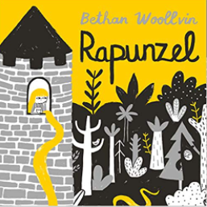

**Year 1 Spring 2, 2023**

**Baubles and Trinkets**

**MUSIC**

This half term we will be introducing our learners to various styles of music from around the world. We will be developing our knowledge and skills of pulse, rhythm and pitch. Alongside this, we will be using BBC Ten Pieces as our resource to expand the skills above.

**RE**

**Why Is Easter the Most Important Festival for Christians?**

* Palm Sunday
* Maundy Thursday
* Easter Sunday
* Good Friday
* Surprises
* How is Easter celebrated?

**PE**

**Indoor:** DDMIX

**Outdoor:** Team Games

**HISTORY**

**Edith Cavell and Remembrance Day**

* Who Edith Cavell was: Where she was born, her life history, how she died
* How she helped soldiers during WW1
* That she helped both British and Germansoldiers

**PSHCE**

**Money and work**

* Strengths and interests; jobs in the community
* Money/Payment
* Importance of saving money

**COMPUTING**

* How to use Google PaintZ
* How to use technology purposefully to create, organise, store, manipulate and retrieve digital content in the context of using a painting program.

**DT**

**Mechanisms**

* Sliders
* Levers
* Presentation Wheels

**SCIENCE**

**Materials**

* Distinguishing between an object and the material from which it is made
* Identifying and name a variety of everyday materials
* Describing the simple physical properties of a variety of everyday materials