## St Matthew’s C. of E. Primary School

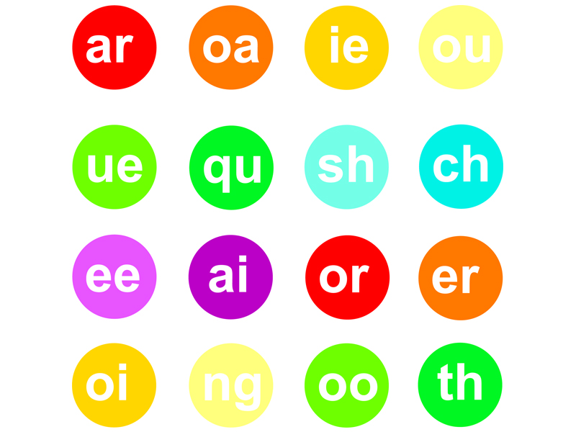

**Year 1 Autumn 1, 2019**

**Baubles and Trinkets**

**Maths**

**Using place value and number facts to solve problems:**

Place value to at least 10:

* counting, reading, representing and writing
* 1 more/ 1 less

Shapes and patterns

* 2D and 3D

Addition and subtraction:

* Number bonds within 10.
* Combination and partitioning

## Literacy

* **The Lost Words**
* Narrative/grammar skills
* We’re going on a bear hunt
* Labels
* Letters
* Captions
* Speech bubbles
* The Great Dog Bottom Swap
* Character description
* Sequencing

**Science - Animals including humans**

* Identify and name a variety of common animals including fish, amphibians, reptiles, birds and mammals
* Identify and name a variety of common animals that are carnivores, herbivores and omnivores

**Music**

* To recognise and explore different sound sources
* To focus their listening and explore instruments
* To control instruments

**RE:**

* What responsibility has God given people about taking care of creation?
* Creation story

**PSHE –**

**Beginning to understand myself and others**

**Promoting British Values - Rule of Law**

Covering our class Golden Rules and signing our school charter

**PE**

* To aim beanbag at a hoop, and swing arm backwards and forwards.
* To experiment with one handed throws and two handed catches with beanbags.
* To send and receive a ball by rolling.
* To show increased control in sending, receiving and travelling with a ball alone, and with a partner.
* To practise bat and ball skills, adapting to learn from experience a lone and with a partner

**Computing – E-safety**

* Use technology safely and respectfully, keeping personal information private.
* Identifying where to go for help and support when they have concerns about online technologies.

**History**

**Toys today and past**

* Looking at toys from the past.
* Looking at present day toys.

**DT**

* Old fashioned toys with moving parts