## St Matthew’s C. of E. Primary School

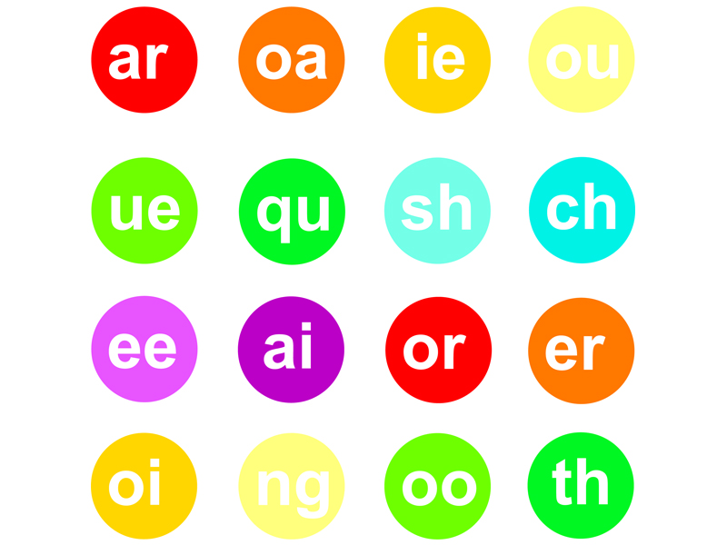

**Year 1 Autumn 2, 2019**

**Baubles and Trinkets**

**Mathematics**

**Solving Problems involving Addition and Subtraction**

* Read, write and interpret mathematical statements involving addition (+), subtraction (–) and equals (=) signs
* Represent and use number bonds and related subtraction facts within 20
* Add and subtract one-digit and two-digit numbers to 20, including zero

## Literacy

* **Out and about**
* Writing about real experiences
* Free verse poetry
* Poetry performances
* The Snowman
* Caption writing
* Descriptive settings

**Music**

* Finding the pulse and rhythm in the Christmas Production songs
* Christmas Production

**Geography – seaside**

* To identify and begin to understand the key physical and human geographical features of the seaside as one example of the broader concept of ‘coasts’.

**PSHE**

***Relationships-Knowing what to do***

* I understand and can explain class/school rules
* I can identify my feelings
* I can set simple but challenging goals for myself
* I can talk about change and loss and the associated feelings
* I can explain how people look after me

**Promoting British Values – Mutual Respect**

Children learn that their behaviours have an effect on their own rights and those of others.

**Science - Animals including humans**

* Identify and name a variety of common animals including fish, amphibians, reptiles, birds and mammals
* Identify and name a variety of common animals that are carnivores, herbivores and omnivores

**Computing**

Introduction to coding, writing and testing simple programs.

**PE**

**Outdoor:** Ball control

**Indoor:** Dance DDMix

**Religious Education**

***Noah, and the Nativity***

* Bible stories – The Nativity Story;
* What Christians believe about the Nativity;
* The importance of the Characters, who they were, and how they impacted on the lives of others;
* Christian living, the Church, ordinary people;
* Belonging and the importance of love, tolerance, respect and faith.

**DT**

* Christmas decorations
* 3D Christmas cards