## St Matthew’s C. of E. Primary School

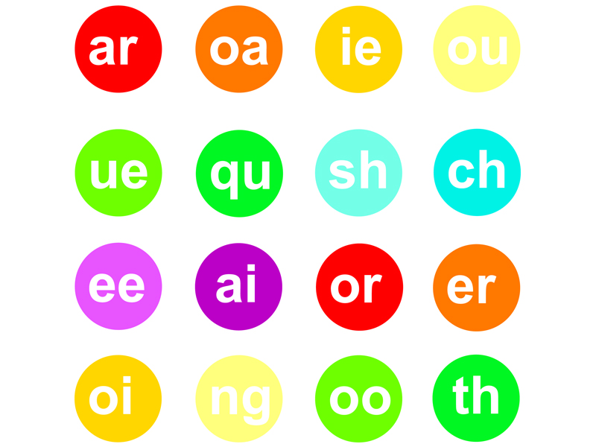

**Year 1 Autumn 1, 2021**

**Baubles and Trinkets**

**Maths**

**Using place value and number facts to solve problems:**

* Place value to at least 10:
* counting, reading, representing and writing
* 1 more/ 1 less
* Shapes and patterns
* 2D and 3D
* Addition and subtraction:
* Number bonds within 10.
* Combination and partitioning

## Literacy

* **The Secret Sky Garden**
* Persuasive writing
* A community gardening project
* **Out And About**
* Performing poems
* Free verse poetry

**Music**

* To recognise and explore different sound sources
* To focus their listening and explore instruments
* To control instruments

**PSHCE**

**Families and friendships**

* Roles of different people; families; feeling cared for

**Safe relationships**

* Recognising privacy; staying safe; seeking permission

**Geography**

**Weather**

* To be able to identify seasonal and daily weather patterns in the UK
* To be able to identify the location of hot and cold areas of the world

**RE**

* What responsibility has God given people about taking care of creation?
* Creation story

**PE**

* To aim beanbag at a hoop, and swing arm backwards and forwards
* To experiment with one handed throws and two handed catches with beanbags
* To send and receive a ball by rolling
* To show increased control in sending, receiving and travelling with a ball alone, and with a partner
* To practise bat and ball skills, adapting to learn from experience a lone and with a partner

**Computing – E-safety**

* To use technology safely and respectfully, keeping personal information private
* To identify where to go for help and support when they have concerns about online technologies

**Science**

**Plant**

* To be able to Identify and name a variety of common wild and garden plants, including deciduous and evergreen trees
* To be able to Identify and describe the basic structure of a variety of common flowering plants, including trees

**Art**

* **Drawing & Collage**
* Local landscapes (meadow and fishponds)