English:
Narrative

We will be basing our literacy on Leon and the Place Between – a wordless picture book about magic and mystery.

We will be using this text to inspire our own narrative writing.

We will also continue with our weekly reading comprehensions.

R.E:
What Is The Bible’s ‘Big Story’?
- What is the Bible?
- What do the concepts of Creation and Fall, People of God, Incarnation and Gospel mean and how do they fit into the big story?
Computing: Coding/Scratch
Children will look at identifying what codes do, what happens when you introduce variables. They will create a times table project.

History: Who were the Anglo Saxons and how do we know what was important to them?
Building on knowledge gained in the autumn term, the children will learn about why the Romans left Britain, who the Anglo Saxons were, how they lived and key figures during this time. The children will also look at important historical places such as Sutton Hoo.

Music: Percussion
We will begin our lessons on percussion with Kingston Wider Opportunities this half term.

DT: Seasonal food
Children will be able to explain that food is grown, reared or caught in the UK and wider world and explain the meaning of seasonality in relation to food.

P.S.H.E: Living in the wider world
The children will begin this topic with a focus on Work and Money. They will consider making decisions about money and using and keeping money safe when looking at realistic saving, planning and budgeting.

Promoting British Values
To reflect on those aspects of our lives which are particularly British and how these differ from other European cultures.

St Matthew’s C. of E. Primary School

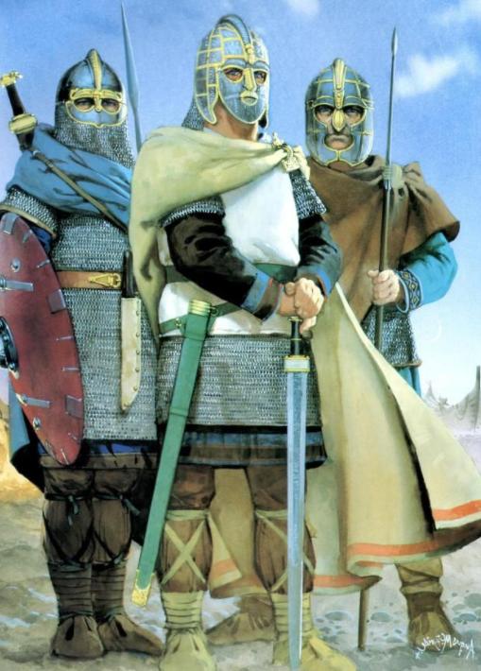

Year 4
Curriculum Outline
Anglo Saxons
Spring Term (1) 2021
REMINDERS:
Your child should be reading every night for at least 15 minutes. Please sign their reading log.

Your child should be completing their MyMaths and learning their spellings every week.
Maths:
Fractions
- Explore different interpretations and representations of fractions
- Equivalent fractions
- Represent fractions greater than one as mixed number and improper fractions
- Add and subtract fractions with the same denominator including fractions greater than one
Time
- Analogue to digital, 12- hour and 24-hour
- Convert between units of time

Science:
Sound
The children will be learning how to identify how sounds are made, associating some of them with something vibrating. They will recognise that vibrations from sounds travel through a medium to the ear and find patterns between the pitch of a sound and features of the object that produced it. We will find patterns between the volume of a sound and the strength of the vibrations that produced it.

P.E:
Dance
We will be continuing with our DDMix lessons – focusing on Scottish dancing until half term.

Squash
The children in year 4 will be learning the basic skills of the racket sport squash. They will learn how to play forehands and backhands, as well as some of the rules of the game at the Surbiton Racket Club.
French: Weather and the water cycle
The children will have the opportunity to:
- Practicing vocabulary linked to the weather
- Learning the cardinal compass points
- Explaining the water cycle

