**LITERACY**

‘Augustus and His Smile’ by Catherine Rayner

* Non-chronological report booklet
* Augustus story

## St Matthew’s C. of E. Primary School

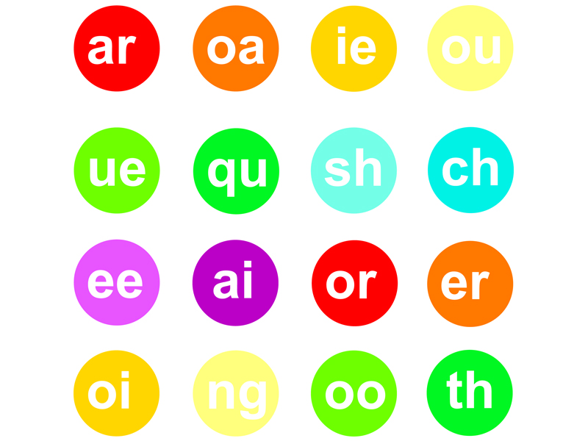

**Year 1 Autumn 2, 2021**

**Baubles and Trinkets**

**Mathematics**

**Solving Problems involving Addition and Subtraction**

* Read, write and interpret mathematical statements involving addition (+), subtraction (–) and equals (=) signs
* Represent and use number bonds and related subtraction facts within 20
* Add and subtract one-digit and two-digit numbers to 20, including zero

**PSHCE**

**Safe Relationships**

Recognising privacy; staying safe; seeking

Permission

**Respecting ourselves and others**

How behaviour affects others; being polite and respectful

**Promoting British Values – Mutual Respect**

Children learn that their behaviours have an effect on their own rights and those of others.

**Computing**

Introduction to coding, writing and testing simple programs.

**HISTORY**

Edith Cavell & Remembrance Day

Significant historical events, people in their own locality & the lives of significant others

**SCIENCE**

**Plants**

* P1 Identify and name a variety of common wild and garden plants, including deciduous and evergreen trees
* P2 Identify and describe the basic structure of a variety of common flowering plants, including trees

**DT**

Structures

Freestanding structures

**PE**

* To master basic movements including running, jumping, throwing and catching, as well as developing balance, agility and coordination, and begin to apply these in a range of activities in the context of moving along different pathways.
* **Indoor:** Dance DDMix

**Religious Education**

***Noah, and the Nativity***

* Bible stories – The Nativity Story;
* What Christians believe about the Nativity;
* The importance of the Characters, who they were, and how they impacted on the lives of others;
* Christian living, the Church, ordinary people;
* Belonging and the importance of love, tolerance, respect and faith.

**MUSIC**

Finding the pulse and rhythm in the Christmas Production songs