St Matthew’s C. of E. Primary School

Year 2
Curriculum Outline
Spring 2 2023

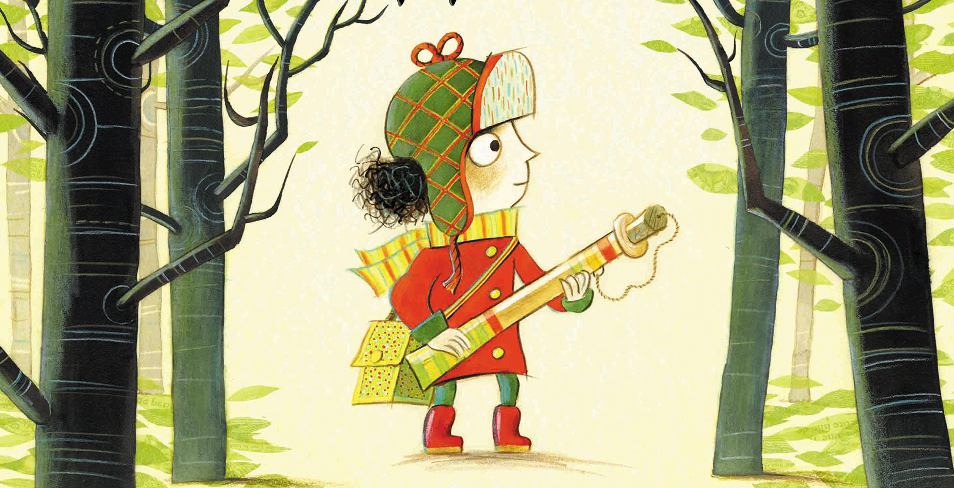

ENGLISH
The Last Wolf
In this half term in English, the children are going to be exploring Mini Grey’s ‘The Last Wolf’ a creative retelling of the classic fairy tale, ‘Little Red Riding Hood’. Through exploring the text in-depth, the children will be encouraged to make links between our book and the well-known story, considering what the similarities and differences are. From studying this text, the children will have many opportunities for writing, including writing in role from different characters, as well as writing for other purposes. The book’s theme of supporting the conservation of nature also links nicely into our forest school sessions and our science topic of habitats.

PSHE – Living in the wider world
In PSHE, the children will be considering their place in the community, exploring different groups that they belong to and their responsibilities within these groups. They will also develop their media and digital literacy, focusing on the internet. The children will also develop an understanding of money and how to look after it.

R.E.
What is the story of Noah really about?
In our first unit in RE this half term, the children will be learning about the story of Noah and build their understanding of the different interpretations of this well-known Bible story. The children will also begin to make links between the beliefs of Christianity and Judaism in relation to the story of Noah.
How do Easter symbols help us to understand the true meaning of Easter?
The children will learn about the different symbols linked to Easter and the importance of their meaning, specifically focusing on the symbol of the cross and water as symbols for forgiveness and new life.
ICT
Multimedia
In computing this half term Year 2 are stepping into the role of news reporters for the SMTV News Channel! The children are going to work in teams to plan and film their own news reports about our learning using our green screen! They will use the iPads to photograph the background image for their report and use the DoInk app to put together their class new report.

HUMANITIES –History
Communication
This half term, the children will be learning about World War I and focus on their various forms of communication, considering how it differs to modern communication. We will focus particularly on the use of messenger pigeons and their role in the war. The children will also describe and suggest reasons why communication was such a challenge during the First World War.
MUSIC
Charanga- Glockenspiels
In music this half term, the children are going to be exploring and developing their playing skills through using the glockenspiel. The children will also further their knowledge and understanding of musical terminology through a hands-on experience with the instruments. They will be introduced to notation and sheet music, as they learn to make connections between musical notations on paper and the matching sound made by the instrument.

Design & Technology
Preparing and cooking Food
In DT this half term, Year 2 are going to be developing their understanding of food and where in the world it comes from, alongside the importance of food hygiene. They will have the opportunity to ask a chef some questions about their job role. Following this, the children will design and create their own pizza, to enjoy eating at the end of term.

MATHS MASTERY
Time
Tell the time on an analogue clock: quarter past, quarter to and five-minute intervals.
Calculate durations of time in minutes and seconds. Sequence daily events.
Addition and Subtraction of 2-digit numbers
Illustrate, represent and explain addition and subtraction involving regrouping including ‘Make 10’, Round and Adjust’ and ‘Near Doubles’ strategies.
Money
Recognise coins and notes and show this using the £ and p symbols accurately.
Adding and subtracting amounts and calculating change.
Face, shapes and patterns; lines and turns.
Explore, sort and describe 2-D shapes
Lines of symmetry in 2-D shapes
Identify 2-D shapes on 3-D shapes
Compare and sort 2-D and 3-D shapes
Use language to describe position, direction and rotation to follow a route

Physical Education:
Football
Over the course of this half term, the children are going to be developing their teamwork through playing football. We will be focusing on developing the children’s ball skills, specifically moving with the ball, passing, dribbling and scoring. We will also be using our knowledge of moving in and out of space from previous units to support our understanding of the game of football.
Dance
The children will be exploring and performing various dances across a variety of dance genres, and creating a range of their own moves.

SCIENCE
Living Things and their Habitats
By exploring what animals and plants need to stay alive, and be healthy, we will look at the seven life processes of movement, reproduction, sensitivity, nutrition, excretion, respiration & growth.

Using our school environment, we will identify both living and non-living things around school, and locate the different habitats we can see, including micro-habitats, e.g. under a log or stone, in leaf litter.

We will also be developing our research skills to find the answers to our own enquiry questions linked to our topic.

