St Matthew’s C. of E. Primary School


Reception
Curriculum Overview Winter 2018-2019
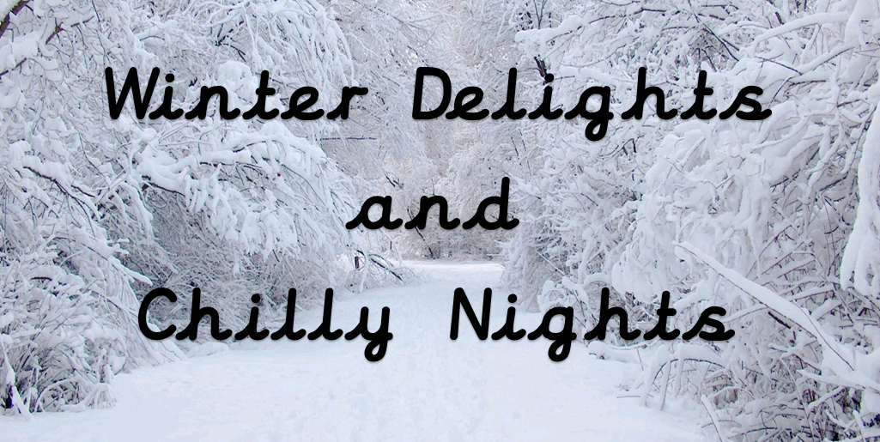

Communication and Language
- Listening and responding
- Asking and responding to questions
- Providing detailed descriptions

Literacy
- Letters and Sounds: Phase 2 & 3
- Re-telling and understanding elements of stories
- Segmenting and blending words
- Handwriting patterns and letters and number formation
- Writing name and other key words
- Power of Reading Key Texts: Blue Penguin, Emperor’s Egg, Lost and Found, The Jolly Postman

Religious Education

- Daily class prayers
- Daily collective worship
- Special celebrations-Christmas and birthdays
- Christmas – Why is Christmas special for Christians?
- 2019: Who Cares for This Special World and Why?

Understanding the World
- Exploring children’s interests and questions from Winter Tree of Learning
- Visits to the nature area – being nature detectives!
- Looking at simple problem solving
- Where animals live – polar animals
- Asking questions about why, where, what, how
- Seasons and Weather – Winter
- Finding out about past and present events in own life and those of family members
- Programmable toys
- Using iPads

Mathematics

- Recognising and ordering numbers
- Simple addition and subtraction
- Doubling and halving
- Create simple patterns
- Developing sense of time
- Positional language
- Capacity
- Weighing
- 2D and 3D shapes

Personal, Social and Emotional Development

- Golden rules and behaviour
- Promoting independence with resourcing and using the new outdoor area layout
- Sharing and turn-taking
- Solving problems independently
- Communicating feelings and needs
- Dressing and undressing – outdoor weather clothes / PE
British Values
- To help pupils distinguish right from wrong

Physical Development

- Following simple instructions
- Music and movement
- Fine motor skills
- Gross motor skills
- Developing hand-eye co-ordination
- Keeping safe
- What it means to be healthy

Expressive Arts and Design

- Exploring colour, texture, shape, form and space in 2D and 3D
- Role-play
- Creating representations of people, places or objects
- Exploring how sounds can be changed
- Learning and singing songs with actions
- Making music using a variety of instruments
- Performing in our outdoor theatre – using puppets, singing, dancing, playwriting and filming productions.

