English
- Descriptions
- Captions

Key text:, The great dog bottom swap, and The Snowman.

St. Matthew’s C of E Primary School

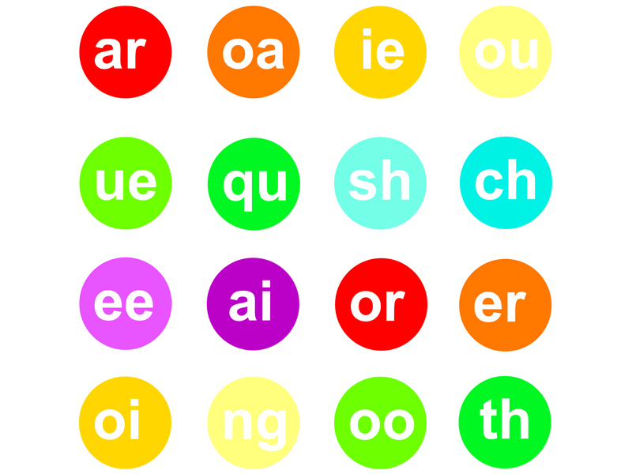

Year 1 Autumn 2 2018
Mathematics
Solving Problems involving Addition and Subtraction
- Read, write and interpret mathematical statements involving addition (+), subtraction (–) and equals (=) signs
- Represent and use number bonds and related subtraction facts within 20
- Add and subtract one-digit and two-digit numbers to 20, including zero

Computing
Introduction to coding, writing and testing simple programs.
Art
- Piet Mondrain using 2 Simple computer programme
- Christmas decorations

Music
- Finding the pulse and rhythm in the Christmas Production songs
- Christmas Production
Religious Education
Noah, and the Nativity
- Bible stories – The Nativity Story;
- What Christians believe about the Nativity;
- The importance of the Characters, who they were, and how they impacted on the lives of others;
- Christian living, the Church, ordinary people;
- Belonging and the importance of love, tolerance, respect and faith.

Science - Animals including humans
- Identify and name a variety of common animals including fish, amphibians, reptiles, birds and mammals
- Identify and name a variety of common animals that are carnivores, herbivores and omnivores
PSHE
Relationships-Knowing what to do
- I understand and can explain class/school rules
- I can identify my feelings
- I can set simple but challenging goals for myself
- I can talk about change and loss and the associated feelings
- I can explain how people look after me
Promoting British Values – Mutual Respect
Children learn that their behaviours have an effect on their own rights and those of others.

Geography – seaside
- To identify and begin to understand the key physical and human geographical features of the seaside as one example of the broader concept of ‘coasts’.
PE
Outdoor: Ball control
Indoor: Dance DDMix
Phonics
Phase 5
Introducing phase 5 sounds:
oy, ir, ue (oo), ue (you), aw, wh, wh (h), ph,ew, oe, au, ey, a-e, e-e, i-e, o-e, u-e,

